IVY TECH COMMUNITY COLLEGE
SDEV 220 Python Programming
Chapter 11

YOUR NAME: ______Giovanna Gorski______________________________________

TO START YOUR PROGRAM
At the top of each of your Python programs, you should have four lines of documentation:
Program name (the Python file name), Author (your name), Date last updated, and Purpose (a brief description of what the program accomplishes). Here is an example:
# Program name: TemperatureConverter.py
# Author: Carl LaFong
# Date last updated: 5/16/2012
# Purpose: Print out your name, address, phone #, and college major

Leave a blank line and then begin to write your program

ASSIGNMENT: : Programming Exercise #1 on page 504, and #3 on page 505.
- Programming Exercise #1 (Employee and ProductionWorker classes):
  - Name the first Python program company_employee.py, to keep it separate from the employee.py file you created for Lab #11. The name of the class is still Employee. The Employee and ProductionWorker classes are both defined in this file.
  - Name the second Python program company_employee_demo.py. This will be the program that creates an instance of a ProductionWorker.
  - Ensure that the employee number is 5 characters long. Hint: Use a validation loop. It does not have to consist only of digits.
  - Ensure that the shift number entered is the value 1 or 2. Hint: Use a validation loop. Remember that the number is an integer.
  - Format the hourly rate with a dollar sign and 2 decimal places. Remember that the number is a
  - There is an example below of what the program interaction might look like. Yours does not have to look exactly like this, as long as it works correctly:
  - Be sure to include the four lines of documentation at the top of each program, and a short comment above every line or small section of Python code.

- Programming Exercise #3 Page 505 (Person and Customer classes):
  - Name the first Python file person.py. This file will define the Person and Customer classes. Write get and set methods for all data attributes.
  - Name the second Python file person_demo.py. This file will create a Customer object, ask for all input information, and display the attributes.
  - In addition to the requirements, write a function in the Person and Customer classes called speak(self). When a Person object calls this function, the program will display “I am a person.” When a Customer calls this function, the program will display “I am a customer.” Write a function in the demo program that calls the speak function to identify the customer calling it.
  - The mailing list attribute is Boolean, so be sure to set it to true or false.
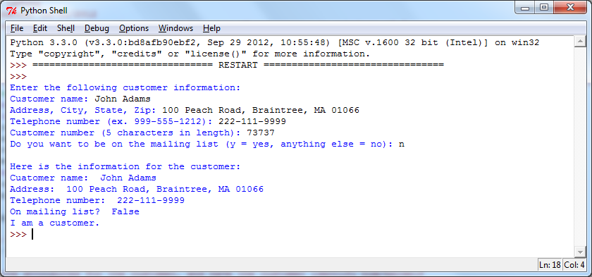
An example of what your program interaction might look like is below. It does not have to be exactly like this, as long as it works correctly:

HOW TO SUBMIT YOUR ASSIGNMENT
Save and close your Python files. In Blackboard, go to the Class Session where this assignment is posted, attach your Python file(s), (Example: jcSalesPrediction.py) and submit for grading. For this assignment, you should submit the class and the employment management system file.
